
Student Name

Teacher Name

School

System

Practice Test

Tennessee End of Course Assessment

Algebra II Form 2


Developed and published under contract with State of Tennessee Department of Education by the Educational Measurement group of Pearson, a business of NCS Pearson, Inc.,2510 North Dodge Street, Iowa City, Iowa 52245. Copyright © 2012 by State of Tennessee Department of Education. All rights reserved. No part of this publication may be reproduced or distributed in any form or by any means, or stored in a database or retrieval system, without the prior written permission of State of Tennessee Department of Education.
PEARSON

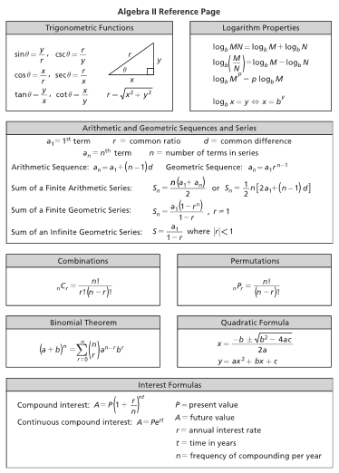

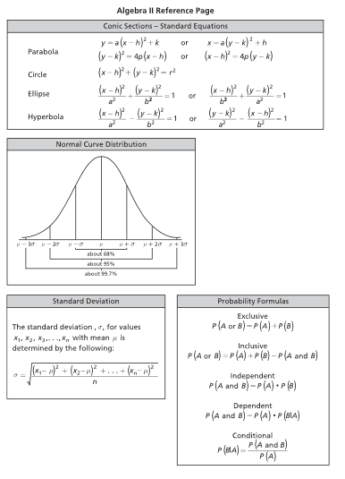
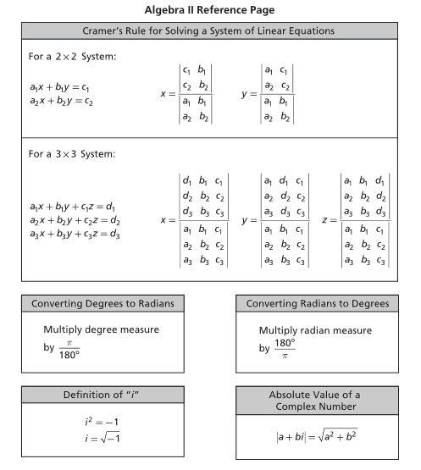

Contents

Introduction to Algebra II 7

Content of tests 7

Test development 7

Test administration 8

Tips for Taking the Test 9

Preparing for the test 9

Before the test 9

During the test 9

Directions for Taking the Practice Test 10

Algebra II Practice Test 11

Answer Key 40

Introduction to Algebra II

Content of tests

The testing program titled the Tennessee End of Course Assessment was established to meet the Tennessee mandate for end of course assessments in Tennessee secondary schools. These tests measure the Tennessee State Performance Indicators. Subject areas covered by the end of course assessments include Mathematics, Language Arts, History, and Science.

Test development

For the Tennessee End of Course Assessment, professional item writers experienced in each of the content areas researched and wrote the items. Professional editors and test developers carefully reviewed all items and test directions for content and accuracy. To provide a large pool of items for final test selection, the test developers created approximately 50% more items as were needed in the final editions of the tests.

After items were field tested, student responses were analyzed. Professional content editors and researchers carefully reviewed items, their data, and test directions for content, suitability, and accuracy before including certain items and test directions in operational tests.
Test administration

Tennessee End of Course Assessments are given to students as they are completing courses that are included in the program. Tests may be given midyear for block schedules or at the end of the school year.

This test contains 51 multiple-choice questions.

You will have ample time to read each of the questions. The Algebra II test has been designed to be administered in one session and is not timed. The first 15 minutes are set aside to complete identifying data on the answer sheet.

A reference page, similar to the one located in this Practice Test, will be in the front of the actual test. This page includes a list of formulas, equations, and tables for use during testing.

Calculator use is recommended. Sharing calculators during testing is not permitted. The following types of calculators/devices may NOT be used during the test:
• pocket organizers
• electronic writing pads or input devices
• Some examples of prohibited calculators are:
o Casio models: CFX-9970G, Algebra FX 2.0
o Hewlett-Packard models: HP-40G, HP-49G
o Texas Instruments models: TI-89, TI-92, Voyage 200, TI-NSPIRE – the CAS
version (The non-CAS version of TI-NSPIRE is allowable.)
• calculators that can communicate (transfer data or information) wirelessly with other student calculators/devices
• cell phones, PSPs, and/or iPods
• Students may use any four-function, scientific, or graphing calculator does not have any of the above features. The use of units that have a Computer Algebra System (CAS) is NOT allowed.

Tips for Taking the Test

Preparing for the test

• Take this Practice Test several times
• Review the Tennessee End of Course Item Sampler for Algebra II located at http://tennessee.gov/education/assessment/sec_samplers.shtml on the Tennessee Department of Education Web site.
• Become familiar with the correct way to mark answers on the answer sheet. There is a sample answer sheet in this Practice Test.

Before the test

• Get a good night’s sleep. To do your best, you need to be rested.

During the test

• Relax. It is normal to be somewhat nervous before the test. Try to relax and not worry.
• Listen. Listen to and read the test directions carefully. Ask for an explanation of the directions if you do not understand them.
• Plan your time. Do not spend too much time on any one question. If a question seems to take too long, skip it and return to it later. First answer all questions that you are sure about.
• Think. If you are not sure how to answer a question, read it again and try your best to answer the question. Rule out answer choices that you know are incorrect and choose from those that remain.

Directions for Taking the Practice Test

In this Practice Test, you will answer various mathematical operations. You may use your calculator and Reference Page located in the front of this book to help you solve the problems. You may write in the open spaces in this book to work the problems, but remember to fill in the circle on your answer sheet that goes with the answer you choose for each question. Fill in the circle completely and make your mark heavy and dark. If you want to change an answer, erase the mark you made and make a new mark.

You will do the items in this Practice Test by yourself. Remember to read all the directions carefully. When you have finished, you may check for answers.

On your answer sheet, find Number 1. Mark your answers beginning with Number 1. You may begin.
Stop when you have finished the test.

At the end of the Practice Test, make sure that all your marks are heavy and dark and that you have completely erased any marks that you do not want.

Turn to 40 and locate the Answer Key. Check your answers and review those items that you marked incorrectly.
1. Which set is the solution set for 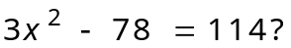
A 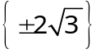
B 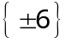
C 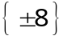
D 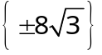

2. What is the sum of 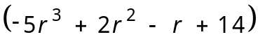 and 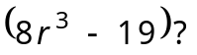
A 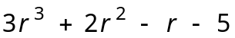
B 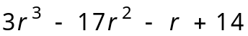
C 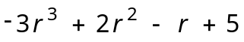
D 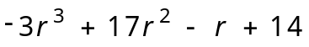

3. The manager of a cell-phone company conducted a survey of 50 teenagers to determine their primary type of cell-phone usage. Among those surveyed, 15 teenagers said texting, 10 teenagers said social networking, 5 teenagers said games, 8 teenagers said phone calls, and 12 teenagers said photos. The manager makes the graph below to represent the survey data.

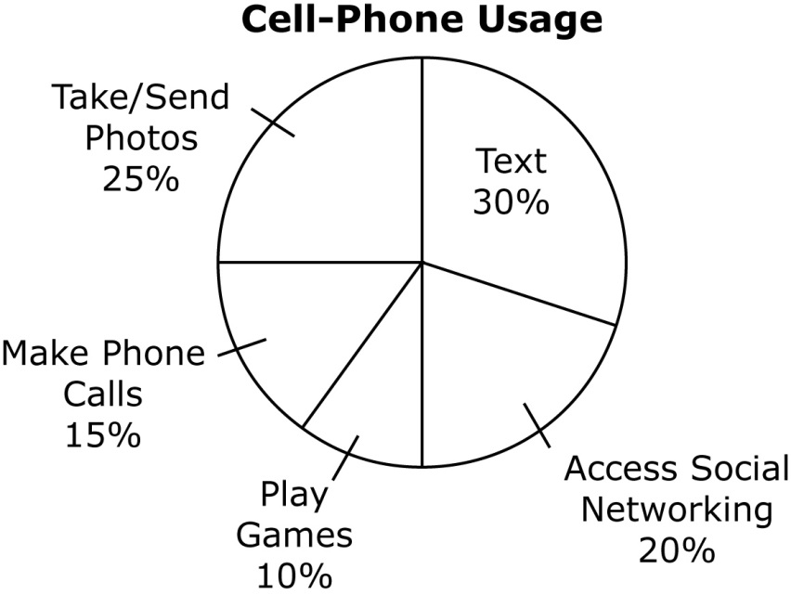

Which statement is true regarding the graph?
A The graph is accurate because the number of respondents represents the correct percentage of the total respondents of the survey.
B The graph is misleading because the data represented in the circle graph does not represent the correct percentage.
C The graph is accurate because the percentages shown in the graph add up to 100%.
D The graph is misleading because a circle graph is not the best way to represent such data.

4. The graph shows the annual revenue of two petroleum companies from 2006 to 2010.
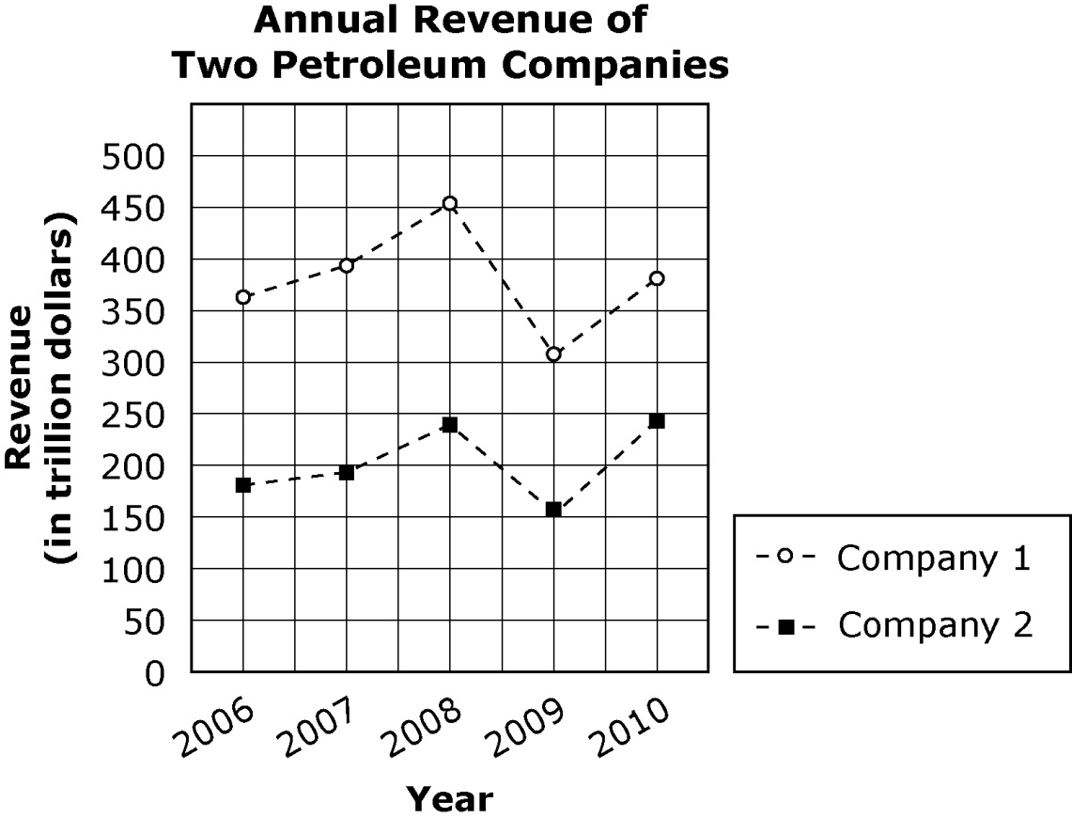
Which statement is best supported by the data in the graph?
A In 2008, the revenue of Company 2 was half of the revenue of Company 1.
B In 2010, the revenue of Company 1 was twice the revenue of Company 2.
C The total revenue of Company 1 was less than the total revenue of Company 2 from 2006 to 2010.
D The mean annual revenue of Company 2 was less than the mean annual revenue of Company 1 from 2006 to 2010.

5. The data below show the time, in seconds, that fifteen students in a swimming class can hold their breath underwater.

38, 48, 37, 54, 29, 37, 28, 47, 45, 50, 41, 34, 40, 60, 58

What is the interquartile range for this data?
A 4 seconds
B 9 seconds
C 13 seconds
D 32 seconds

6. A battery manufacturer randomly selects one battery each from two different batches of batteries produced in a factory for testing. The table below shows the number of nondefective and defective batteries in the two batches of batteries.

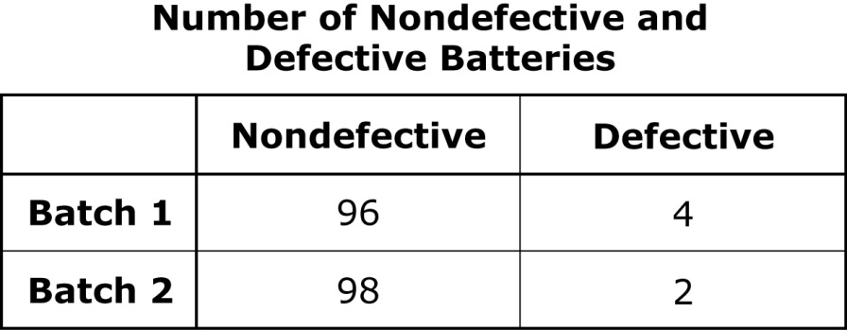
What is the probability that the battery manufacturer picks a defective battery first from batch 1 and then from batch 2?
A 0.0008
B 0.0192
C 0.0392
D 0.9408
7. Simplify the expression 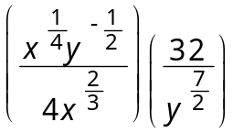 for all 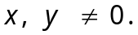
A 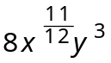
B 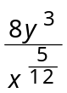
C 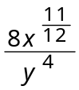
D 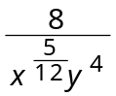

8. What is the value of 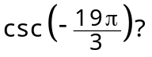
A 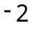
B 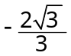
C
D 2

9. Kristen builds a pathway of uniform width, x, in feet, around her rectangular flower garden. The garden is 22 feet long and 18 feet wide. What is the area, A, in square feet, of the garden including the pathway?
A 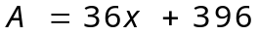
B 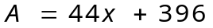
C 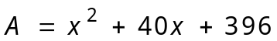
D 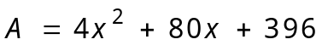

10. The mean of a normal distribution is 70 with a standard deviation of 5. If a value is randomly selected from this distribution, which is closest to the probability that the selected value is greater than or equal to 75?
A 0.16
B 0.34
C 0.66
D 0.84

11. What is the domain of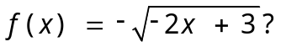
A 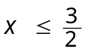
B 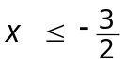
C 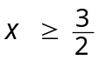
D 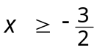

12. Which graph best represents the system of inequalities below?
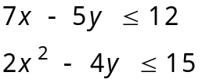

A  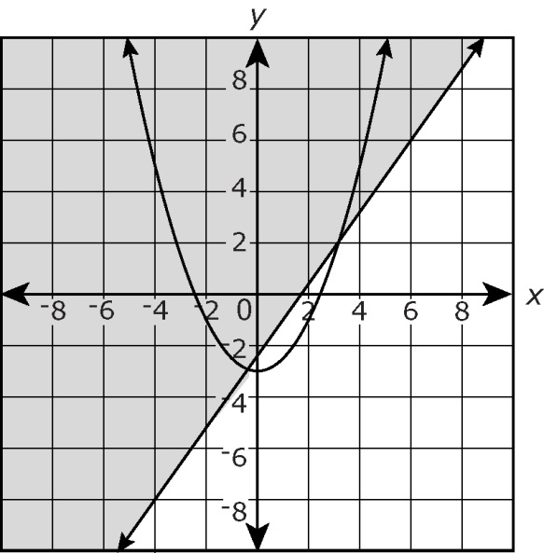 | C  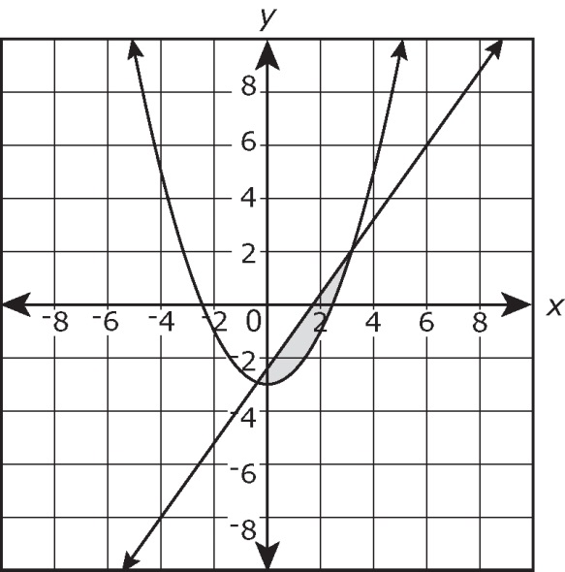
B  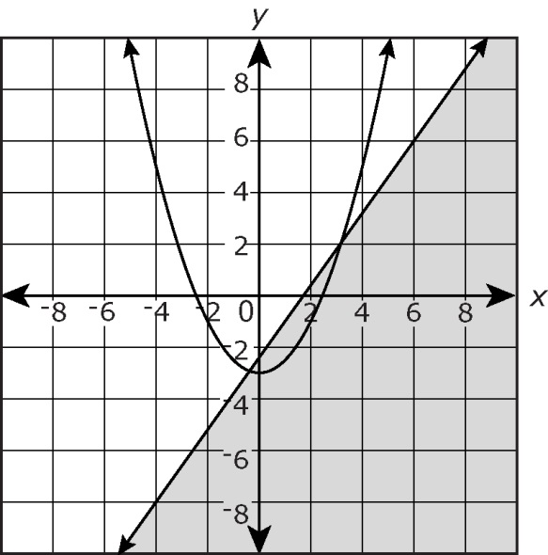 | D  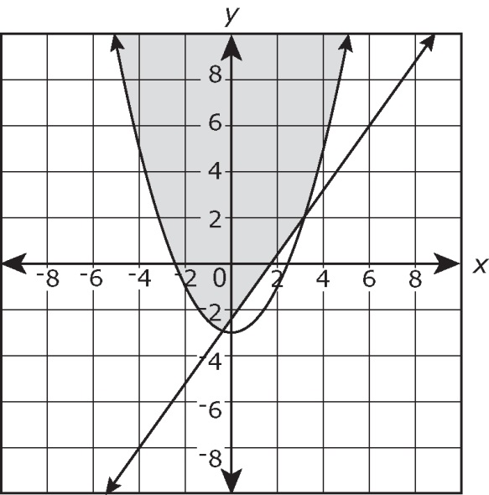

13. Which number must be subtracted from 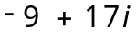 to get 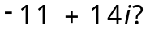
A 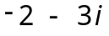
B 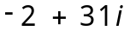
C 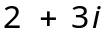
D 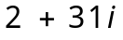

14. The average time, in minutes, spent by nine students talking on the phone each day is given below.
14, 5, 10, 12, 16, 9, 8, 12, 4
Which is closest to the value of the standard deviation of the given data?
A 1.2 minutes
B 3.7 minutes
C 10 minutes
D 14 minutes

15. John finds the roots of the equation 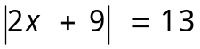 using the following steps.
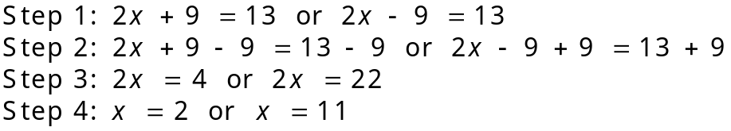
Which step is the first incorrect step?
A Step 1
B Step 2
C Step 3
D Step 4
16. Which expression is equivalent to 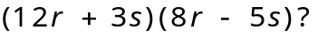
A 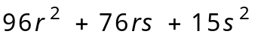
B 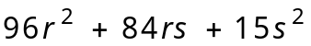
C 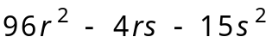
D 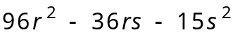

17. Which pair of functions are inverses of each other?
A 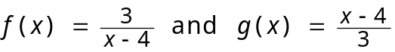
B
C
D 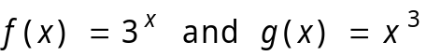

18. The table below shows a plant nutrient (in nutrient tons) used by cotton farmers from 2001 to 2009.
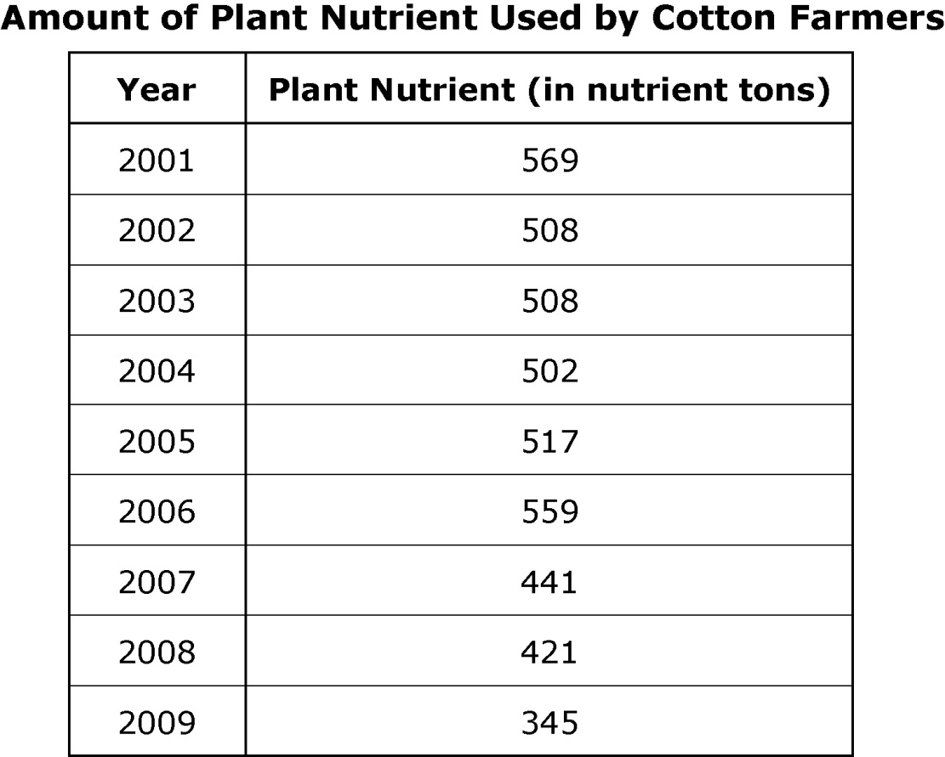
Which best describes the linear correlation of the plant nutrient from 2001 to 2009?
A Weak positive correlation
B Weak negative correlation
C Strong positive correlation
D Strong negative correlation

19. Which equation best represents the relationship between the x and y values in the table below?
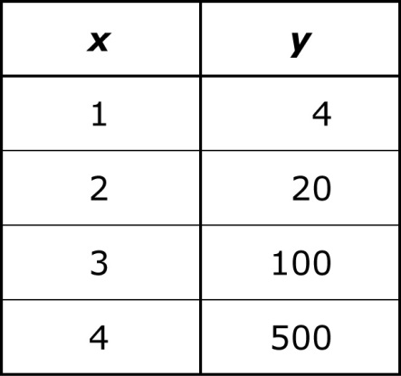
A 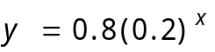
B 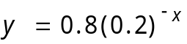
C 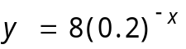
D 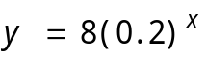

20. Which graph best represents one cycle of 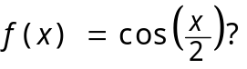
A  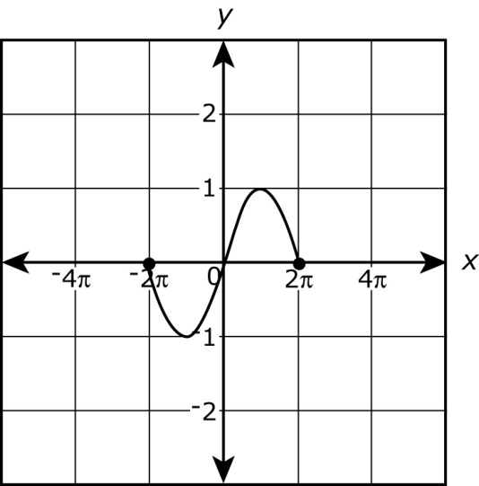 | C  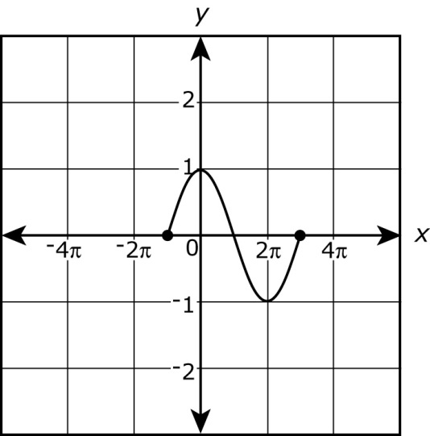
B | D  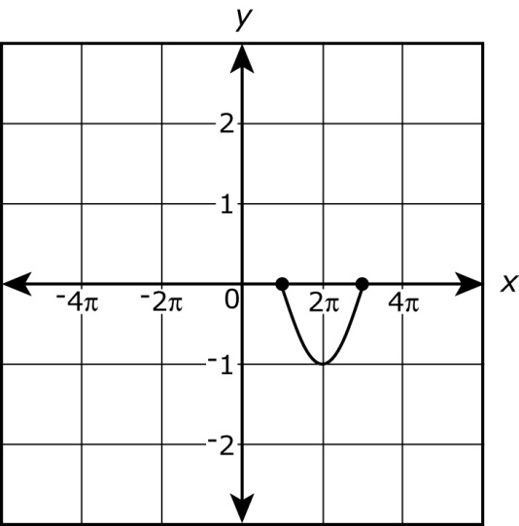

21. Which expression represents the quotient of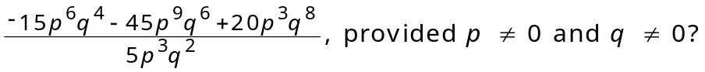

A 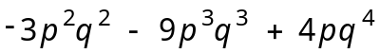
B 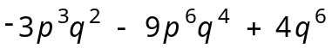
C 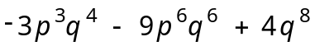
D 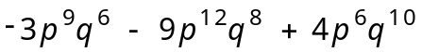

22. The scatterplot below shows the number of vehicles sold by an automobile company over a ten-month period.
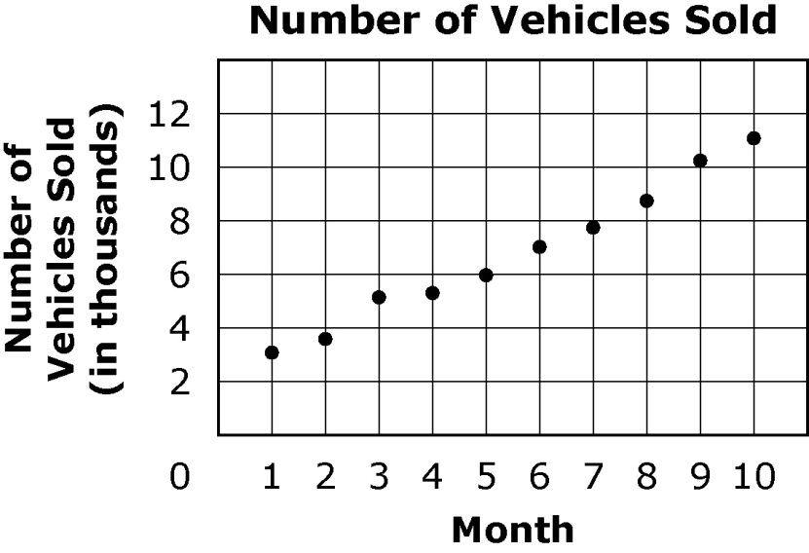
Which type of function do the data points best represent?

A linear
B quadratic
C exponential
D logarithmic
23. The following data, in kilograms, give the amounts of potatoes grown using two different types of fertilizers.
Fertilizer A: 25, 29, 19, 15, 18, 23
Fertilizer B: 27, 28, 18, 20, 19, 26
Which statement about the two sets of data is true?
A The mean of the data for fertilizer A is greater than the mean of the data for fertilizer B.
B The median of the data for fertilizer A is greater than the median of the data for fertilizer B.
C The standard deviation for the data for fertilizer A is greater than the standard deviation for the data for fertilizer B.
D The interquartile range in the data for fertilizer A is greater than the interquartile range in the data for fertilizer B.

24. One cycle of a trigonometric function is graphed below.
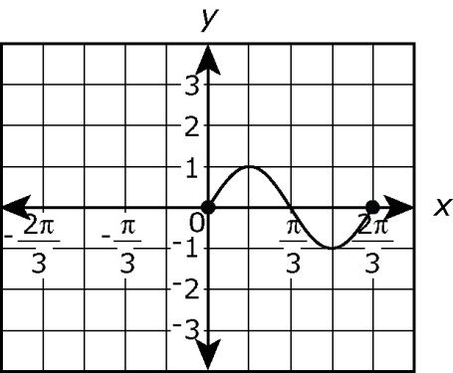
Which function is best represented by this graph?

A 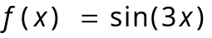
B 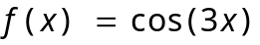
C 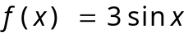
D 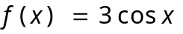

25. The half-life of cobalt-60 is 5.27 years. The mass of a sample, y, in mg, present at time, t, in years, is represented by the equation 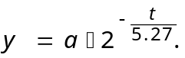 If the initial amount, a, of a sample is 60 mg, after how many years will the amount left be 3.75 mg?

A 9.27 years
B 15.81 years
C 21.08 years
D 26.35 years

26. What is the solution set for the equation 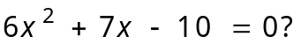

A 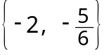
B 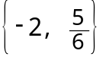
C 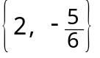
D

27. Which graph represents the inverse of 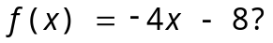

A  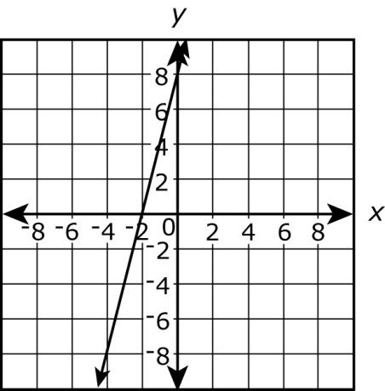 | C  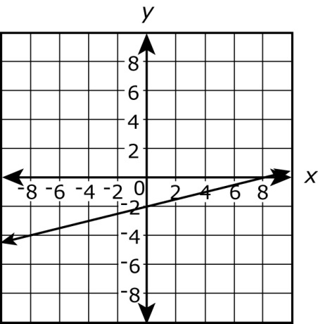
B  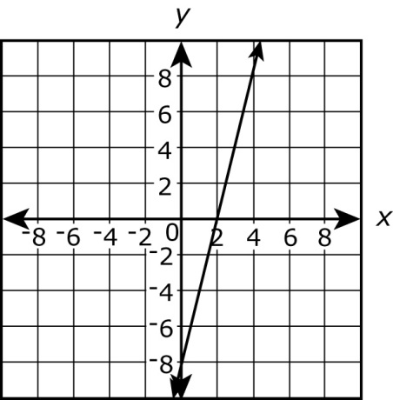 | D  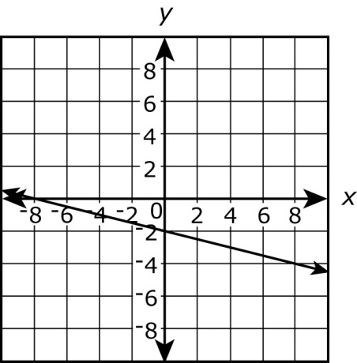

28. Mike and Lynn entered a jump rope contest. The table below shows the number of consecutive jumps in five attempts.
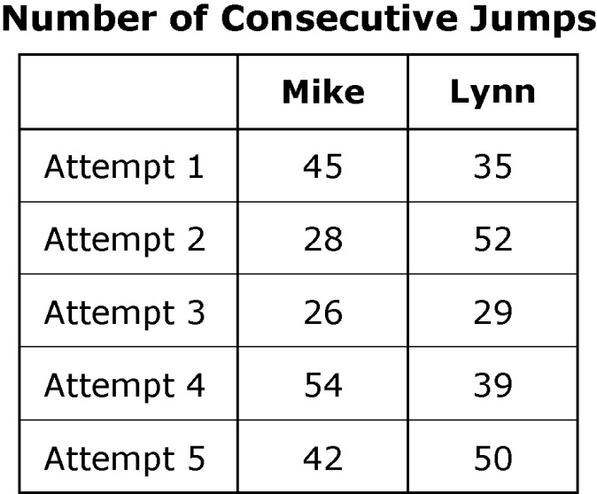
Which statement best compares Mike’s data to Lynn’s data?
A Mike’s data has a lesser mean and a lesser standard deviation than Lynn’s data.
B Mike’s data has a lesser mean but a greater standard deviation than Lynn’s data.
C Mike’s data has a greater mean but a lesser standard deviation than Lynn’s data.
D Mike’s data has a greater mean and a greater standard deviation than Lynn’s data.

29. What are all the roots of 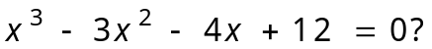
A 2 and 3
B 2 and -2
C 2, -2, and 3
D 2, 3, and -3
30. Which expression is equivalent to 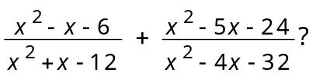

A 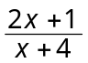
B 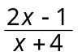
C 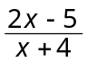
D 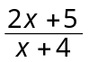

31. The table below shows the foraging performance of honeybees.
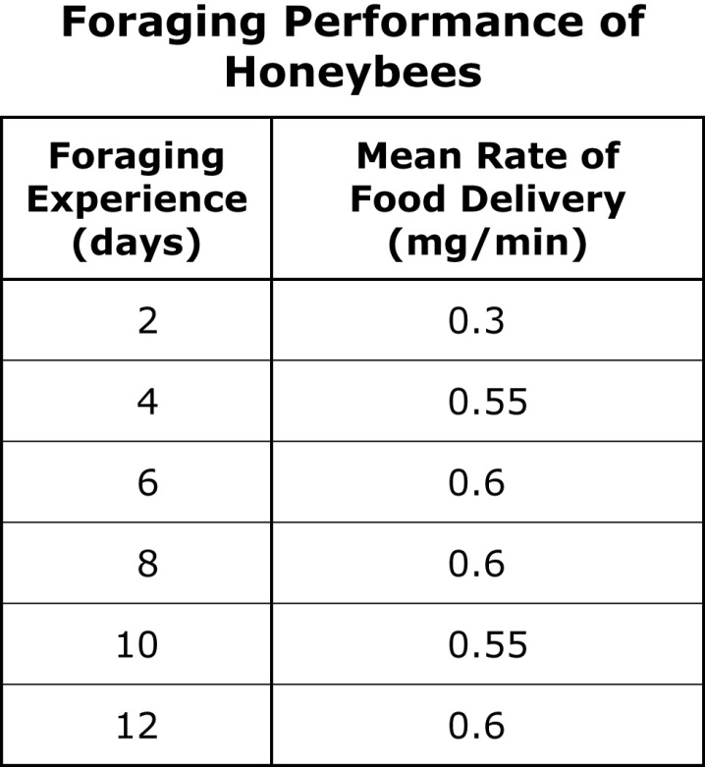
If the data is modeled by a quadratic equation, which rate is closest to the mean food delivery rate in milligrams per minute (mg/min) on Day 7?
A 0.15 mg/min
B 0.45 mg/min
C 0.53 mg/min
D 0.61 mg/min
32. What is the sum of the infinite geometric series below?
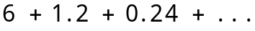
A 7.5
B 7.2
C 5.0
D 4.8

33. Jack earned a score of 74 on an aptitude test whose scores are normally distributed. The mean test score is 62 with a standard deviation of 6. If a student is randomly selected, which is closest to the probability that the student’s score is greater than or equal to Jack’s score?

A 0.975
B 0.525
C 0.475
D 0.025

34. Which expression is equivalent to 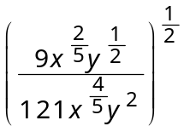 for all 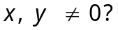
A 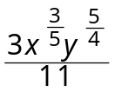
B 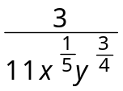
C 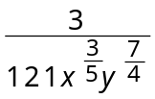
D 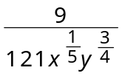

35. Samantha recorded the amount of money she had left at the end of each day of her vacation.
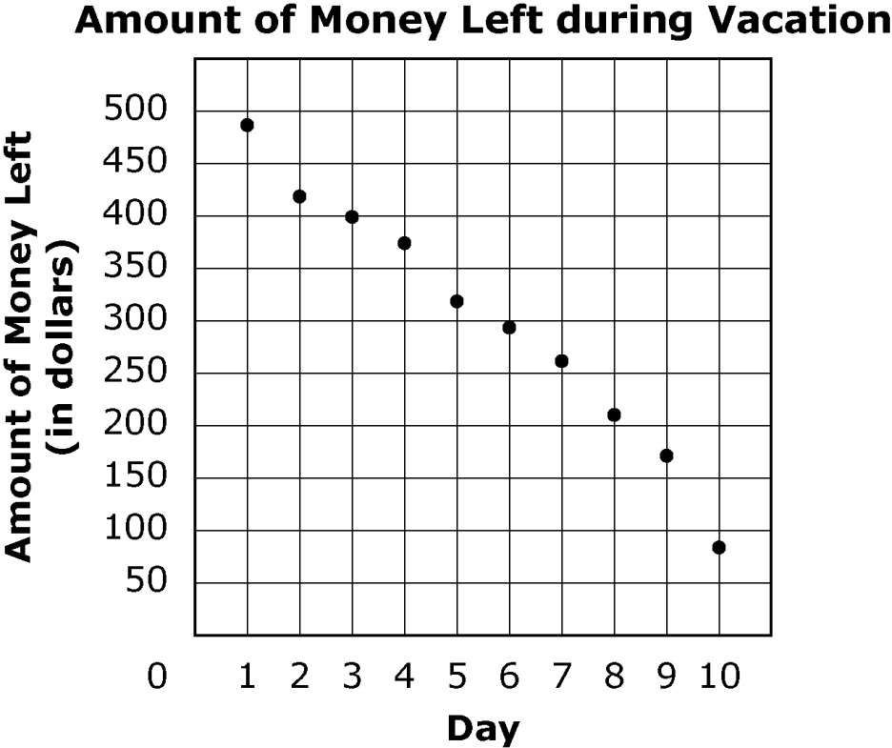
Which type of function do the data points best represent?

A linear
B quadratic
C exponential
D logarithmic

36. What is the 10th term of the sequence below?
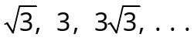
A 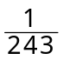
B 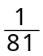
C 243
D 729

37. What is the standard form of 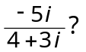
A 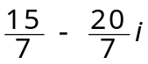
B 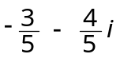
C 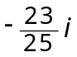
D 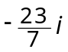

38. What is the solution to the system of equations?
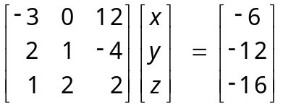
A  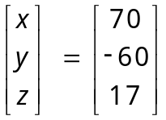 | C  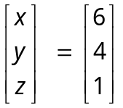
B  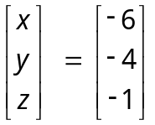 | D  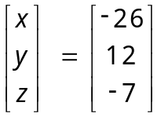

39. Which value of x makes this equation true?
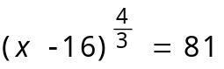
A 43
B 27
C 25
D 19

40. The table below shows the prices for a particular brand of television.
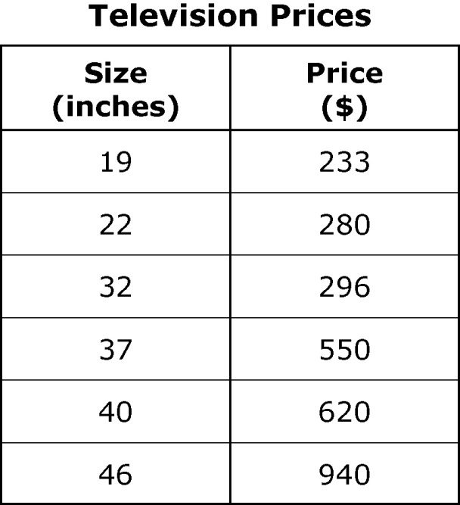
If the data are modeled by a quadratic function, which is closest to the price of a 20-inch television?
A $186
B $234
C $248
D $310

41. What is the range of the function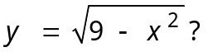
A all real numbers greater than and equal to 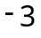 and less than and equal to 3
B all real numbers greater than and equal to 0 and less than and equal to 3
C all real numbers greater than and equal to -9 and less than and equal to 9
D all real numbers greater than and equal to 0 and less than and equal to 9

42. The number of bacteria in a sample can be modeled by the equation 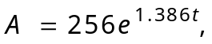 where t is in hours. In approximately how many hours will there be 16,384 bacteria?
A 1 hour
B 2 hours
C 3 hours
D 4 hours

43. The graph below shows the relationship between the percent scores of students in a certain class and their class rank.
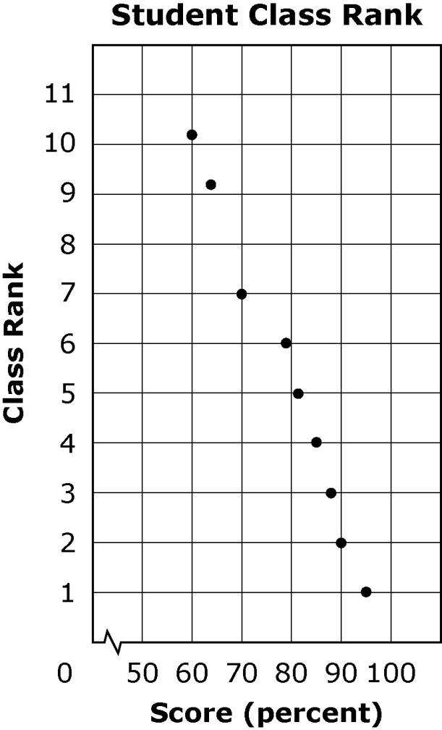
Which value is the best estimate for the correlation coefficient?
A 0.99
B 1
C -1
D -0.99

44. The graph shows the per capita personal income of Tennessee’s metropolitan and nonmetropolitan areas.
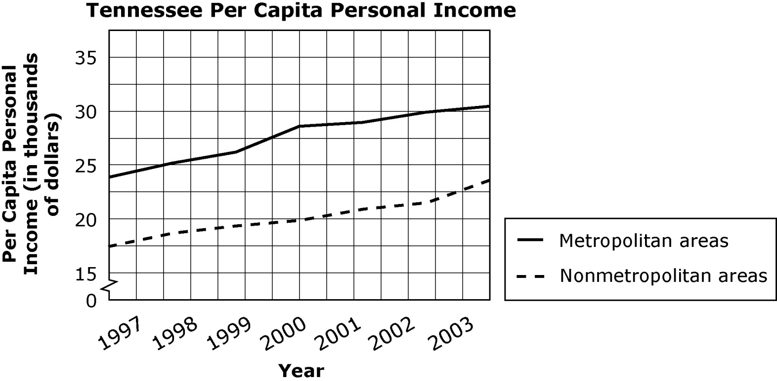
Which statement about the data shown is true?
A The nonmetropolitan areas have a greater annual mean of per capita personal income than the metropolitan areas.
B The nonmetropolitan areas have a greater range of per capita personal income than the metropolitan areas.
C The percent of increase of the sum of per capita personal income of the metropolitan and nonmetropolitan areas from 1997 to 2003 is about 29%.
D The percent of increase of the difference between the per capita personal income of the metropolitan and nonmetropolitan areas from 1997 to 2003 is about 53%.

45. Susan and Lisa each work two different part-time jobs. Both girls are paid the same amount per hour for yard work and the same amount per hour for tutoring. The table below shows the number of hours they each work and the total amount they earn.
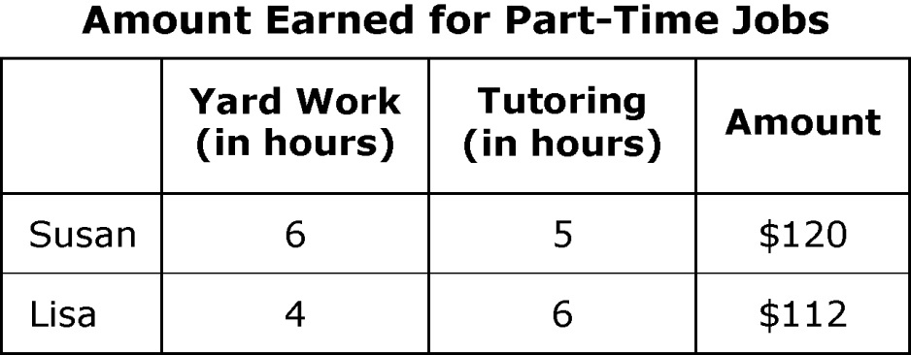
How much do Susan and Lisa earn per hour for yard work?
A $10
B $12
C $21
D $23

46. Ron, a juggler, randomly picks one ball each from three different bags. The table below shows the number of blue, red, and green balls in the three bags.
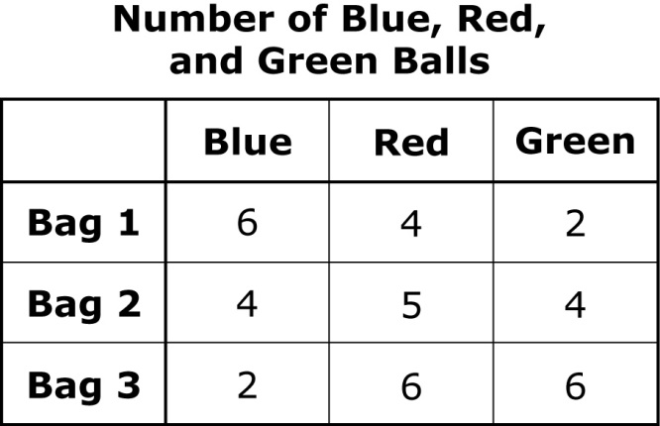
What is the probability that Ron picks a red ball from bag 1, a blue ball from bag 2, and a green ball from bag 3?
A 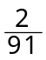
B 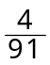
C
D 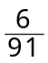

47. Which degree measure is equivalent to 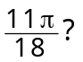
A 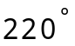
B 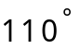
C 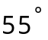
D 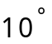

48. A local community college conducts a survey to determine the percent of high school seniors in the community who want to attend the college in the fall term following their graduation. Which of these samples will provide the most accurate results?
A every 15th high school senior from each high school roster
B every high school senior who is taking AP Statistics
C every 15th student on the roster attending the fall term at the college
D every senior attending the graduation ceremony

49. Which system of inequalities is best represented by the shaded region below?
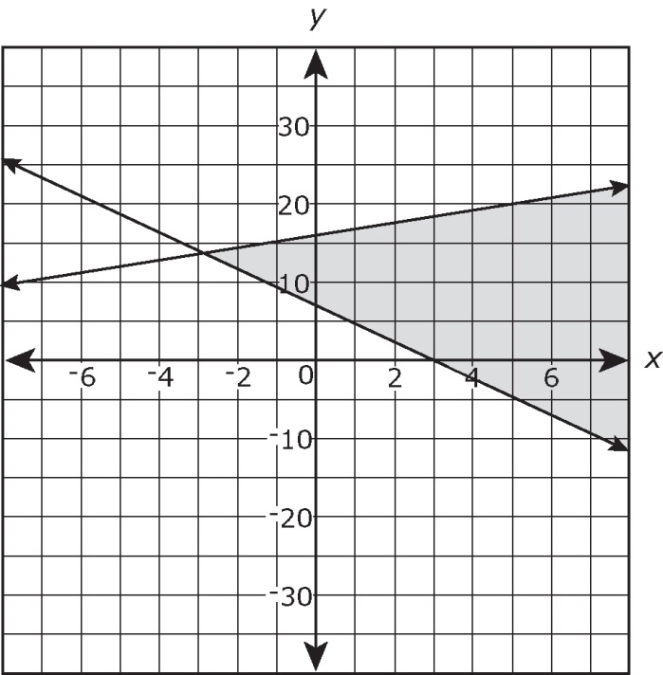
A 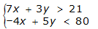
B 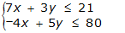
C 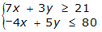
D 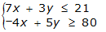
50. A research institute is studying the effects of exercise on memory power among healthy adults in their 60s. Which scenario describes an observational study?
A Find 100 volunteers, 50 of whom exercise three days a week, and 50 of whom do not exercise. Give the volunteers memory tests at the beginning, middle, and end of the study; analyze the data; and draw conclusions.
B Find 100 volunteers who regularly exercise. Assign 50 of them to stop exercising for the duration of the study. Give the volunteers memory tests at the beginning, middle, and end of the study; analyze the data; and draw conclusions.
C Find 100 volunteers who do not exercise. Assign 50 of them to start exercising three days a week. Give the volunteers memory tests at the beginning, middle, and end of the study; analyze the data; and draw conclusions.
D Find 100 volunteers who do not exercise. Assign all of the volunteers to start exercising three days a week. Give the volunteers memory tests at the beginning, middle, and end of the study; analyze the data; and draw conclusions.

51. What values of x make this equation true?
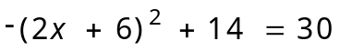
A 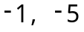
B 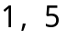
C 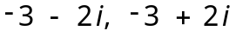
D 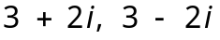

Answer Key- Algebra II
Question | SPI | Answer |  | Question | SPI | Answer
1 | 3.2 | C |  | 27 | 3.7 | D
2 | 3.1 | A |  | 28 | 5.2 | B
3 | 1.2 | B |  | 29 | 3.2 | C
4 | 3.12 | D |  | 30 | 3.3 | D
5 | 5.1 | C |  | 31 | 1.3 | D
6 | 5.8 | A |  | 32 | 3.4 | A
7 | 3.3 | D |  | 33 | 5.4 | D
8 | 4.1 | B |  | 34 | 3.3 | B
9 | 1.1 | D |  | 35 | 5.3 | A
10 | 5.4 | A |  | 36 | 3.4 | C
11 | 3.5 | A |  | 37 | 2.2 | B
12 | 3.9 | D |  | 38 | 3.8 | D
13 | 2.2 | C |  | 39 | 2.3 | A
14 | 5.1 | B |  | 40 | 1.3 | C
15 | 1.4 | A |  | 41 | 3.5 | B
16 | 3.1 | D |  | 42 | 3.13 | C
17 | 3.7 | C |  | 43 | 5.7 | D
18 | 5.7 | D |  | 44 | 3.12 | C
19 | 1.1 | B |  | 45 | 3.13 | A
20 | 4.2 | C |  | 46 | 5.8 | B
21 | 3.1 | B |  | 47 | 4.1 | B
22 | 5.3 | A |  | 48 | 1.2 | A
23 | 5.2 | C |  | 49 | 3.9 | C
24 | 4.2 | A |  | 50 | 5.5 | A
25 | 2.3 | C |  | 51 | 2.3 | C
26 | 3.2 | B

